Women & War : A Post-October 7th Perspective

We invite you to join the Israel Women’s Network (“IWN”) for a presentation and discussion in which we will examine the profound impact the events of October 7th had on Israeli women. IWN’s leadership will discuss the sexual violence, the military heroism, the displacement of people, the state of small businesses, many of which are women owned, the chaos caused to the educational system which affects women in particular, the adverse impact on women due to the lack of separation between state and religion, the fight for gender representation in all aspects of Israeli society and other topics relevant to the audience.

**THE IWN**

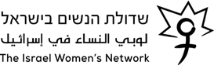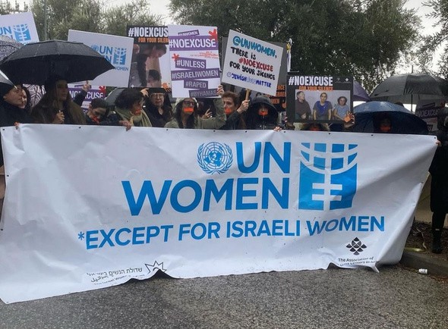The IWN is Israel’s leading women’s rights organization dedicated to advancing gender equality in Israel. For 40 years, the IWN has championed women’s rights through political advocacy, legal challenges and policy change. We support women from all walks of life, particularly those facing multiple forms of discrimination. Since the events of October 7th the work of IWN has been even more challenging. Despite facing numerous obstacles, the IWN has witnessed many positive changes including a growing public recognition of the importance of women in decision-making, acknowledgment of the significant contributions of women during the war and an increased awareness of the fact that without gender equality, there is no democracy.

**Panelists and topics**

# Prof. Dafna Hacker - incoming Chairwoman

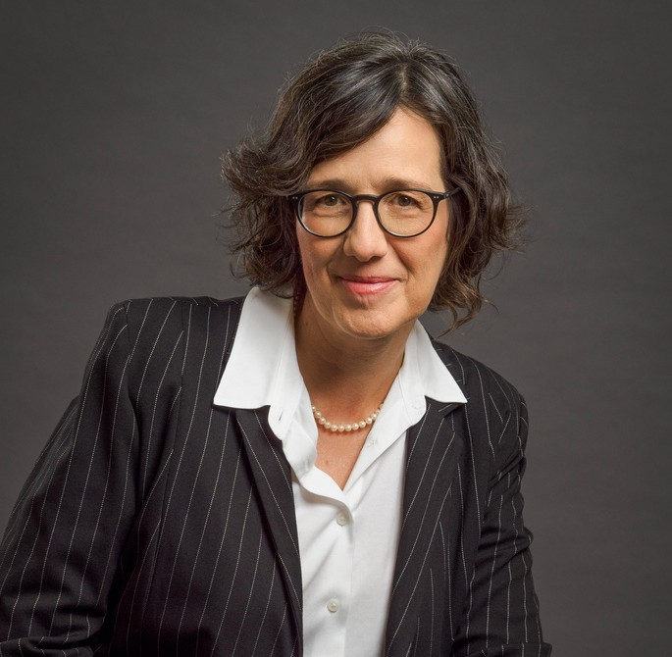Prof. Hacker will explore, through a gender lens, Israeli society after the murderous attacks of Hamas on October 7 and the impact of the ensuing war on women in the IDF. The current war in Gaza came at a time of an internal backlash on women’s rights in Israel. While female soldiers repeatedly demonstrated their courage and capabilities, their future role in the IDF is threatened by the plan to recruit Ultra-Orthodox men. Moreover, the burden on women has intensified as they are called upon to care for their evacuated families in the South and the North while the fathers/husbands are called into service for months at a time. These challenges are made all the more difficult as women are not in general a part of many decision making processes despite their leadership in many civil society activities.

# Elah Alkalay - Outgoing Chairwoman

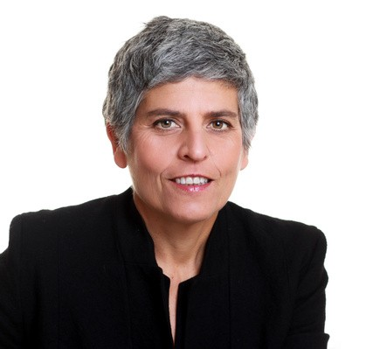Elah will discuss Alice Shalvi’s legacy and the Alice Shalvi Women’s Rights Response Center. She will describe the background of the IWN, what we have learned so far post-October 7 and what the IWN has achieved and hopes to achieve in the future. Elah will also discuss the relationship among government, NGO’s and the business community.

# Tal Hochman - Executive Director

Tal will address the events of October 7th, shedding light on the various facets of sexual violence that occurred and the reaction by the Israeli government and others internationally to these crimes. Through an analysis of eyewitness accounts, expert testimony, and current research, Tal will raise awareness about what actually happened and what should and must be done next on the national and international levels to address such violence and to ensure it does not take place in the future.